The needs of Karamoja
The Anglican Diocese of the North West Australia sent the Rev. Daniel Faricy, Dr. Khim Harris, and retired Bishop Gary Nelson to Karamoja, Uganda in May to run biblical training programs.

It was raining. It was dark. 5:30am we made our way to the cathedral, a new building which took about 12 years to build, to meet together with our brothers and sisters in Karamoja for church.

Karamoja is a place of great need. Most people are subsistence farmers. Drought these past few years has made this difficult for many. Bishop Joseph, of the Karamoja diocese, reports that in the next few months, many will die as a result of famine. It is rainy season at the moment, and God in his providence has provided rain – everyone is busy preparing their fields planting sorghum, maize and beans but they won’t be ready to harvest until August.

Most ministers who are serving the needs of the gospel don’t receive a stipend from their church as their church is too poor. Lay Leader John, leads a church about 10km from town that has no building – their church had a covered area until recent winds blew the roof off, and yet has over 300 kids in their Sunday school. He doesn’t receive payment for his services to them. Yet, he greeted us with a smile and with a joy that characterise so many Ugandan Christians.

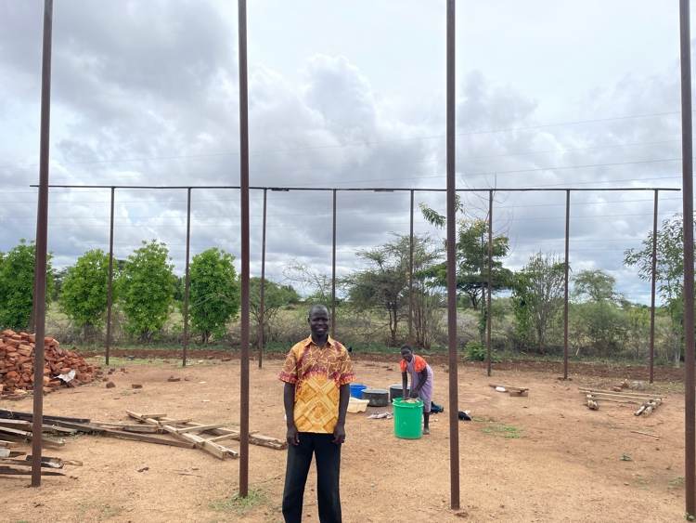
Lay Leader John and his church building with no roof.

The physical needs of the people are overwhelming, especially coming from rich Australia where we are more likely to ask which food should we eat, not where will our food come from. The Karamojan diocese does what it can, supporting a local health clinic near one the villages, investing where it can in schooling – for example it built a local high school, St. Andrew’s, and when funds are available helping those without food.

Karamoja is also a place of great spiritual need. There is a battle going on in Karamoja for peoples souls. Local African Traditional Religions (ATR) are strong; with locals worshiping at shrines and making sacrifices to the gods of the elders, Islam is on the rise and the Roman Catholic Church is active in recruitment. More than ever Karamojans need to hear the good news of the gospel, of how ‘God is a great God, and a great King above all gods’ (Psalm 95:3) and how he sent his Son Jesus into the world to save the world.

Praise God for the Anglican Church in Karamoja who seeks to faithfully proclaim the gospel. There are currently 35 clergy and 25 lay leaders who lead the church in Karamoja. Like John (above) they serve in challenging places with little financial support, yet they serve their God with joy, evangelising, preaching, running Sunday schools. When they meet, their praise is amazing, with choirs from local schools and a bit of African dancing to praise the Lord, the Anglican liturgy we know well in Australia is used, and most importantly God’s word is preached.

The proverb goes, ‘iron sharpens iron, and one man sharpens another’ (Proverbs 27:17) and it was great to help sharpen the preaching of these faithful ministers. As part of the team from the Diocese of North West Australia, we came and ran some training in biblical theology and how to preach from the Psalms, we gave them tools such as 2 ways 2 live, a tool for reading the Bible (COMA – Context, Observation, Meaning, Application) and the bible overview which they can use in their churches. Layleader John (above) was of those ministers. The Rev. Daniel (not the author) commented, ‘it is so good to see how the Psalms and the whole bible points to Christ’, another expressed their thanks ‘we’re so happy you could come and run this training’. They look forward to us hopefully coming again one day in the future, and the announcement that we’re continuing this partnership of dioceses was met with great applause whenever it was mentioned.
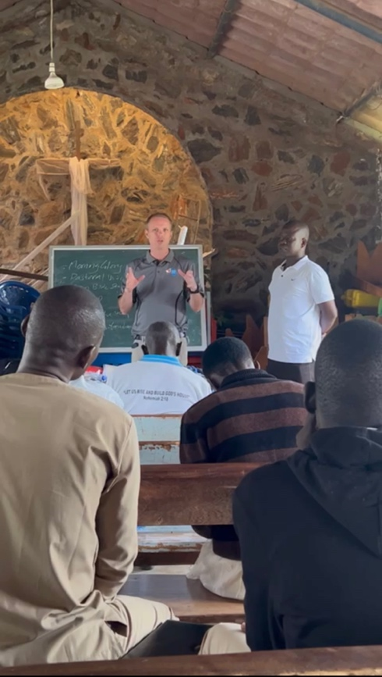
The Rev. Daniel Faricy training the Lay Leaders

It’s worth mentioning too that sharpening also goes both ways. Being in the Karamoja culture showed me how our desire for comfort in the West often stops us from taking up our cross for Jesus. Lay Leader Alfred rides his push bike 40-50km in the heat to visit someone and share the gospel with them, and then does the same the next day every week. Ministers in Karamoja sign up knowing that there isn’t going to be nice superannuation package when they retire and that there will be no reliable income. While they have training, many would love a much deeper understanding of the bible, and yet they keep preaching Christ. Keep denying themselves. We have much we can learn from our brothers and sisters in Karamoja.

As we left the cathedral after that 6:00am service at 8:45, it was hard not to be encouraged by what God is doing in Karamoja through his saints in the midst of great need. Please keep Karamoja and Bishop Joseph and his ministers in your prayers!

By Rev. Daniel Faricy

